OFFER LETTER TEMPLATE(Update January 7, 2021)

[Date]

[Student Name]
[Student Address]

Dear [Student Name]:

Congratulations! You have been selected to receive an L&S Community of Graduate Research Scholars Fellowship (known across campus as the Advanced Opportunity Fellowship) at the University of Wisconsin-Madison for the academic year [upcoming academic year]. This selective fellowship program represents a partnership between your graduate program, the Graduate Research Scholars community, the College of Letters and Science, the Graduate School, and the Office of the Vice Chancellor for Research and Graduate Education with funding from the Wisconsin Alumni Research Foundation (WARF) and the State of Wisconsin. We commend you on your accomplishments and look forward to the contributions you will make to our community of scholars.

We believe that the Letters & Science Community of Graduate Research Scholars (CGRS) Fellowship has many benefits. As a summary, we are offering the following comprehensive funding package as part of your fellowship:
- a stipend of [C-Basis $22,909; A-Basis $28,000] covering the period [C-Basis 8/23/2021-5/22/2022; A-Basis 9/1/2021-8/31/2022],
- payment of all tuition and segregated fees during the fellowship period,
- eligibility for health insurance during the fellowship period,
- a $600 Welcome Payment for your personal use,
- eligibility for subsequent L&S CGRS support (see the attached Terms and Conditions of L&S CGRS Fellowship for eligibility criteria), and
- participation in the L&S Graduate Research Scholars program. This program connects you with a community of Graduate Research Scholars for networking and social, academic, and professional development activities throughout your graduate career.
As an L&S Community of Graduate Research Scholar, you will receive much more than just the funding package described above. You will also participate in program activities designed to create a network of supportive peers among diversity graduate students in the College of Letters and Science, in partnership with our faculty and staff within the University of Wisconsin community. We believe we have created an environment where students can develop valuable social and professional ties (both formal and informal) with new and continuing scholars in the program. We also provide an array of professional development opportunities that will benefit you in your career development.

The addendum to this letter, Terms and Conditions of L&S CGRS Fellowship, provides detailed information about your fellowship. Please read it carefully as it outlines important benefits, eligibility criteria, and obligations of your fellowship.

The final page of the Terms and Conditions of L&S CGRS Fellowship also includes a Fellowship Offer Response Form that you should return to [departmental contact name, email, address]. Like other graduate programs to which you are applying, we subscribe to the resolution of the Council of Graduate Schools in the United States which does not require a decision from you until April 15, [current year]. Of course, if you know your response before that date, we hope you will let us know as soon as possible, but in any event we ask for a written decision by April 15, [current year].

Again, congratulations. We look forward to your participation in our graduate community.

Sincerely,

[Name]

Terms and Conditions of L&S C-GRS Advanced Opportunity Fellowships
[insert upcoming academic year]

Contacts:

Shirin Malekpour, Associate Dean for Teaching & Learning Administration
(608) 265-2506, shirin.malekpour@wisc.edu
305 South Hall, Bascom Mall, Madison, WI 53706

Nova Tebbe, Project Assistant
(608) 890-3850, adminpa@ls.wisc.edu
307A South Hall, Bascom Mall, Madison, WI 53706

L&S C-GRS website: http://www.ls.wisc.edu/cgrs.html

Important Information about your Fellowship
Scholar name: [name of fellow]
Fellowship period: [C-Basis 8/23/2021-5/22/2022; A-Basis 9/1/2021-8/31/2022]
Total stipend amount: [Total stipend amount paid in 9- or 12- monthly installments]
First stipend check available: [C-Basis 9/9/2021; A-Basis 9/23/2021]

Tuition and Segregated Fees
Your fellowship covers the full cost of tuition and segregated fees during the fellowship period stated above. There is a one-time $65 fee for official documents that is not covered by the fellowship. If you have a nine-month (September-May) appointment and wish to take credits during the summer following your L&S CGRS fellowship, you will be responsible for paying the in-state tuition rate for those credits.

Health Insurance Benefits
For the fellowship period listed above, you are eligible to receive health insurance. To learn more about the health insurance options and premiums, you can visit the following website: http://www.benefits.wisc.edu\grads.

Welcome Payment
At the start of the first year of your UW-Madison graduate student career, you will receive a $600 Welcome Payment meant for your personal use. The welcome payment is intended to help with your expenses until your first regular stipend is paid.

Housing Priority for Incoming Fellows
If you are interested in obtaining housing through the university, please go to: https://www.housing.wisc.edu/apartments/. Pending availability, incoming Advanced Opportunity Fellows are given priority in housing assignment at Eagle Heights and Harvey Street apartments. To apply, fill out the online application, and indicate in the University Status section that you have a “Graduate School fellowship.”

Full Time Study (Registration)
All L&S CGRS Fellows must register full time during all terms in which you have a fellowship appointment. If you do not register by the end of the first week of classes, we will hold your stipend check. Full-time study for non-dissertators is a minimum of eight (8) credits of graduate level coursework (courses numbered 300 and above) each fall and spring semester. Dissertators must register for three (3) credits. Students with fellowship appointments over the summer must also register for a minimum of two (2) graduate credits during the eight-week (DHH) summer session (dissertators three [3] credits). You must take this coursework for grades rather than as audits or for Pass/Fail. A progress grade in Research & Thesis (990) is acceptable.

Satisfactory Progress
Fellows must make satisfactory progress toward their graduate degrees. Satisfactory progress is at the discretion of a student’s program, the Graduate School, and a student’s faculty advisor. At a minimum, the Graduate School requires that students maintain a graduate GPA of at least 3.00 in all graduate-level work (300 or above, excluding research, audit, credit/no credit, and pass/fail courses) taken as a graduate student unless probationary admission conditions require higher grades. The Graduate School also considers Incomplete (I) grades to be unsatisfactory if they are not removed during the subsequent semester of enrollment; however, the instructor may impose an earlier deadline. Future funding is dependent on satisfactory progress toward your degree.

Participation in L&S CGRS/AOF Community Activities
All first-year Fellows are required to attend all L&S CGRS events that occur during the fall and spring semester. This is so regardless of whether you choose to defer your fellowship to a later year. The events are designed to provide you with useful professional development opportunities, as well as regular interactions with other incoming Fellows from different departments across the college.

There are approximately 3-5 events each semester, and events are scheduled in the early evenings so as not to interfere with your courses. You will receive a schedule for the events with your confirmation letter, but the same event schedule may be accessed at any time at the following URL: https://kb.wisc.edu/ls/page.php?id=45754.

Additional Funding Support

- Eligibility for additional L&S CGRS support
You may be eligible to receive a second year of L&S CGRS Fellowship support if you are enrolled in either a PhD or professional master’s program (contact the graduate coordinator in your program if you have questions about your eligibility for this second year of support). The second year of support covers tuition and segregated fees and conveys a benefits package and stipend. You are eligible for this second year of support only if you (i) are in your second year of a professional Master’s program or (ii) are enrolled in a PhD program and have achieved dissertator status prior to the beginning of the academic year for which you are to receive your second year of L&S CGRS support.

- Funding beyond the L&S CGRS fellowship period(s)
At UW-Madison, there are several different types of student appointments you may hold during the course of your graduate studies. These include fellowships, graduate assistantship positions such as teaching assistantships, project/program assistantships, research assistantships, lecturer (SA) positions, and student hourly positions. The terms and conditions of those appointments may vary from year to year or from term to term. Unlike fellowships, graduate assistantships and student hourly positions require work obligations; have different stipends for different work levels; and provide differential coverage of tuition, segregated fees, and health insurance. To learn more about graduate assistantships in general, you can visit this website: http://uwmadisonoffr.wordpress.com/funding-overview/assistantships/

Note that your funding support may change during the years which are not covered by this fellowship. Please check with your program’s coordinator to get the details of future funding. For each future appointment, you should ask for the following information:
- type of position (e.g., research assistantship, teaching assistantship);
- start and end dates;
- percentage of the appointment/number of work hours required (e.g., 50% appointment = 20 hours a week);
- stipend amount;
- tuition coverage;
- payment of segregated fees, if applicable ($734/semester and $363/summer term 2020-21);
- eligibility for health insurance; and
- additional benefits, if any (e.g., travel funds, professional development funds, priority for graduate student housing, etc).

Concurrent Appointments
Along with your L&S CGRS fellowship, you may hold concurrent graduate assistantships and/or student hourly appointments up to a total maximum combined annual stipend of $49,632 (2020-21 maximum). Please be aware that this policy may vary depending on the type of fellowship you hold; if you have any questions about concurrent work along with any fellowships you may hold in the future, please feel free to contact the Office of Fellowships and Funding Resources.

Financial Aid with Fellowships
If you are applying for financial aid, please be aware that your fellowship could affect your eligibility. You must inform the Office of Student Financial Aid (608) 262-3060 and any granting agency of all types of support you receive, including fellowships. This is to ensure appropriate calculation of financial need. If you need short-term financial assistance, contact the Office of Student Financial Aid. .
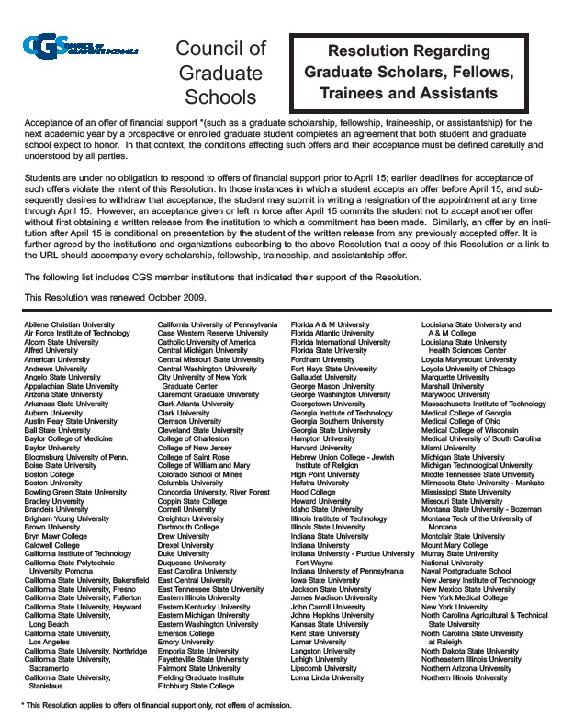
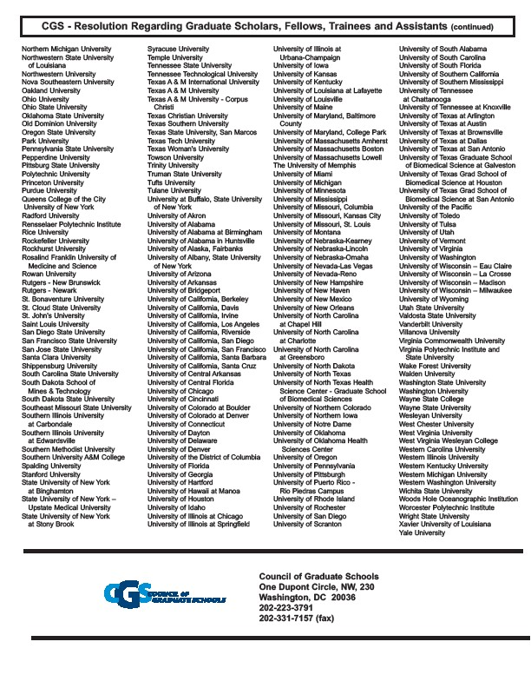

FELLOWSHIP OFFER RESPONSE FORM

Please return this form by April 15th to: contact name, address, email
In accordance with the policy of the Council of Graduate Schools, a response
is not required before April 15th

Name:

University of Wisconsin Campus ID#:

I have read the offer letter and the accompanying Terms and Conditions of L&S C-GRS Advanced Opportunity Fellowships, and I wish to: (check one)

q ACCEPT the fellowship that has been offered me.

q DECLINE the fellowship that has been offered me.

*******************************************

q I am an INCOMING student interested in receiving priority for University Housing as described in the Terms and Conditions document

