**SAGE Vantage Deep Linking Guide for Canvas**

This document will walk you through the steps for creating deep links in your Canvas course to connect to SAGE Vantage.

We recommend that you create links in the Modules area of your course, although you could also use the Pages area of your course. Using Modules tends to give the smoothest user experience. You do not need to create Assignments in Canvas to match your SAGE Vantage assignments, as that is done automatically with the integration.

You can add a module specifically for your SAGE Vantage content, or you can embed the Vantage links within existing content (for example, if you set up your Canvas course with a module for each chapter).

Choose the module where you would like to add a Vantage link, and click on the “+” button.

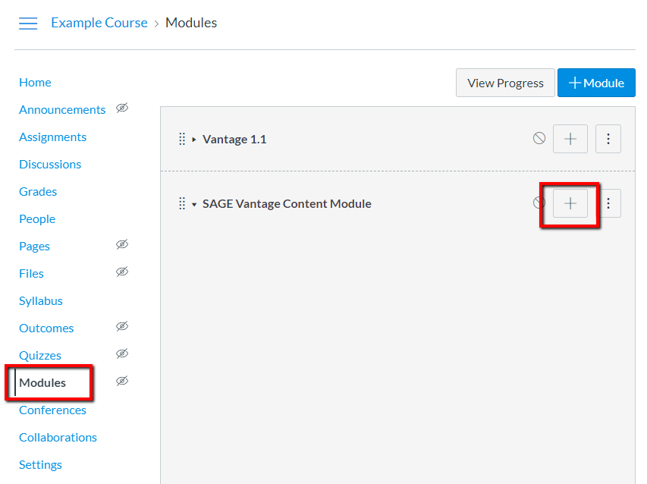

In the “Add” dropdown, select External Tool.

From there, you will see a list of available tools. Choose the one that says SAGE Vantage.

**Note:** the actual link text will depend on how your administrator set up the app. We recommend using SAGE Vantage, but it may just be Vantage, or something similar.

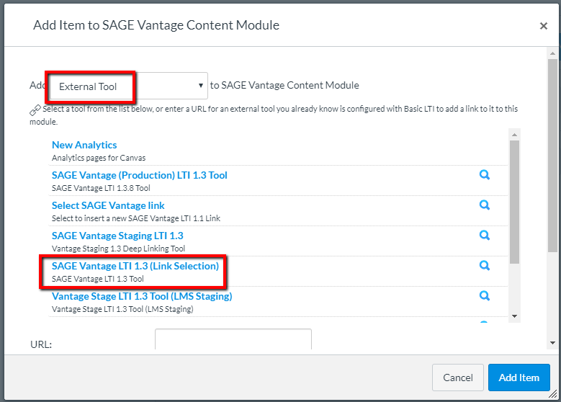

Choose your Vantage course that you want to link to your Canvas course. If you only have one Vantage course, it will automatically be selected for you.

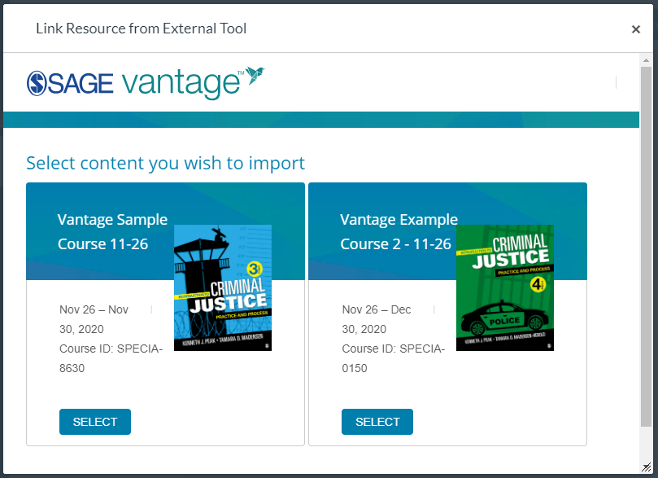

There are three dropdowns on the link selection page. Each of these dropdowns is a filter that allows you narrow the list of items you have to choose from, to make it easier to find the desired content. We recommend using only one filter at a time.

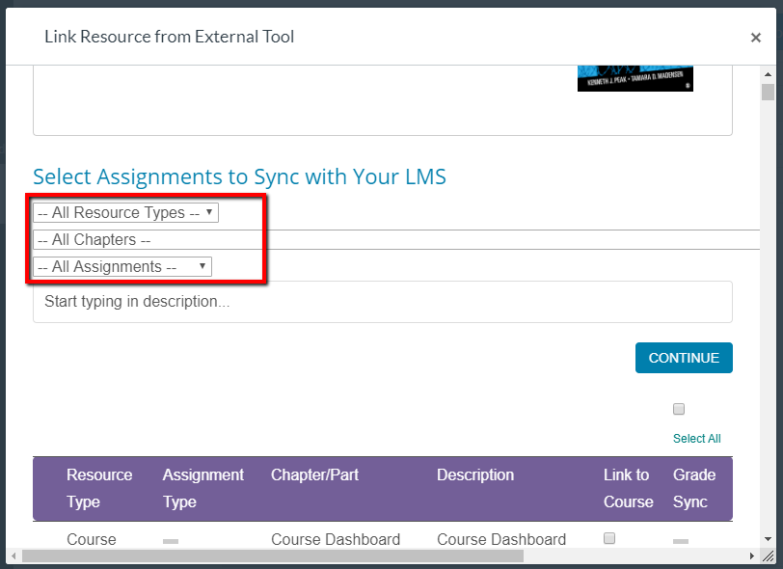

There are two columns you can select. The left column is the link that will appear in your course. The right column will determine if grades for that item will be sent to Canvas. Note that items that are not gradeable in Vantage will not have a checkbox in the right column.

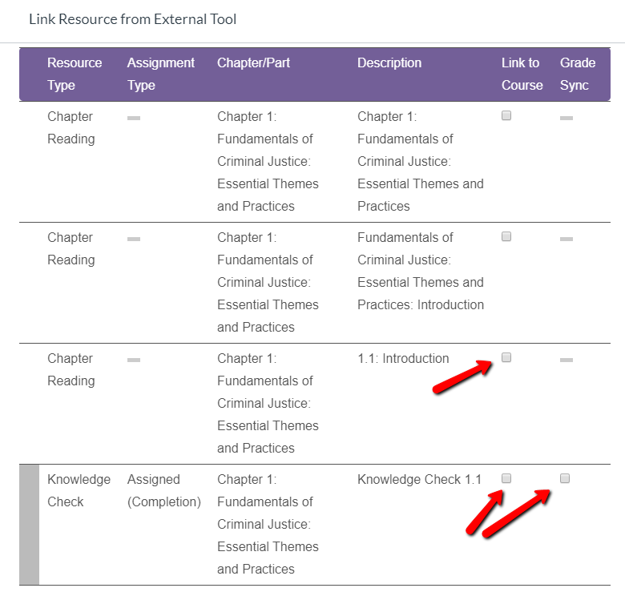

Canvas allows the creation of either one link at a time or multiple links at a time.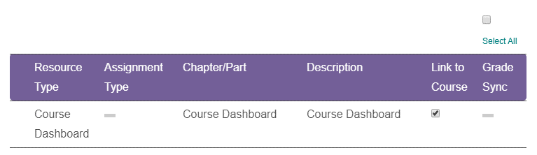

You can select to sync grades for more than one assignment at a time, either by selecting multiple items in the right column, or by clicking in the “Select All” box at the top of the right column.

When you choose to Grade Sync items, those items will appear in the Canvas Grade Center, and will have a corresponding assignment created in the Assignments area of the course; however, the assignments created in Canvas will not allow users to cross over from Canvas to Vantage. They are essentially placeholders in Canvas so the integration knows where to send the grades.

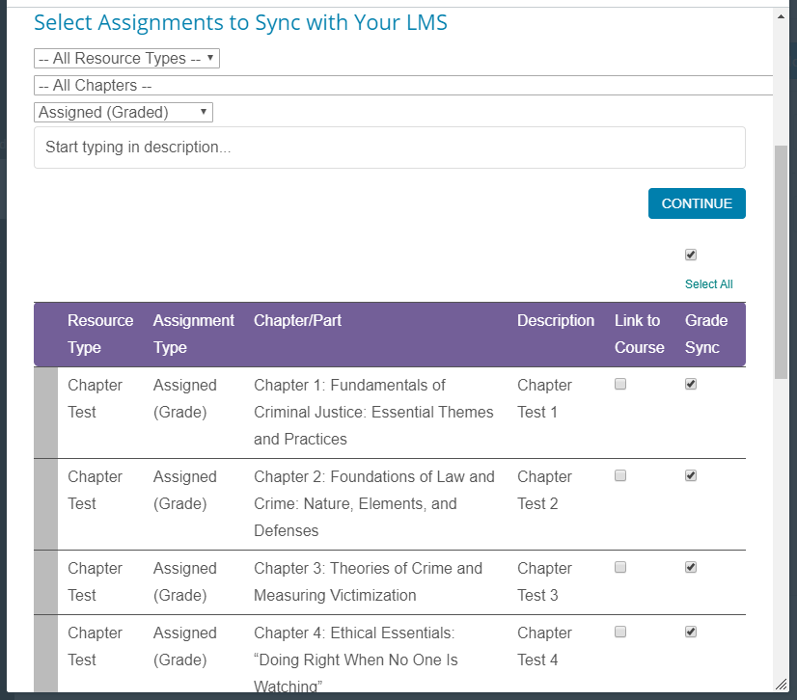

Once you’ve made your selections, you will be taken to a confirmation page.

**Important Note:** please take the time to review your selections! Extra links can be easily removed, but you cannot un-sync a grade item without assistance. If you mistakenly select an item to grade sync, please contact us at [LMSsupport@sagepub.com](mailto:LMSsupport@sagepub.com) for help.

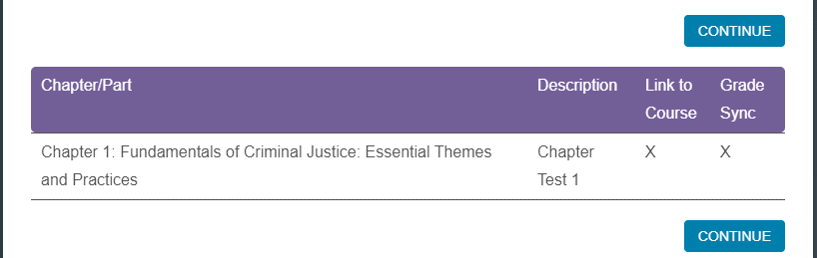

Click “Continue,” and you will go back to the Canvas content selection page.

**Note:** Canvas has recently updated their platform, and you can now choose to create one link at a time, or you can create multiple links at once.

**IF YOU ARE SELECTING ONE LINK AT A TIME**   
There will be a web address in the URL field, and the Page Name will be set to the name of the linked item in Vantage. CAN YOU can edit the name if you wish, and we recommend that you select the “Load in a new tab” checkbox.

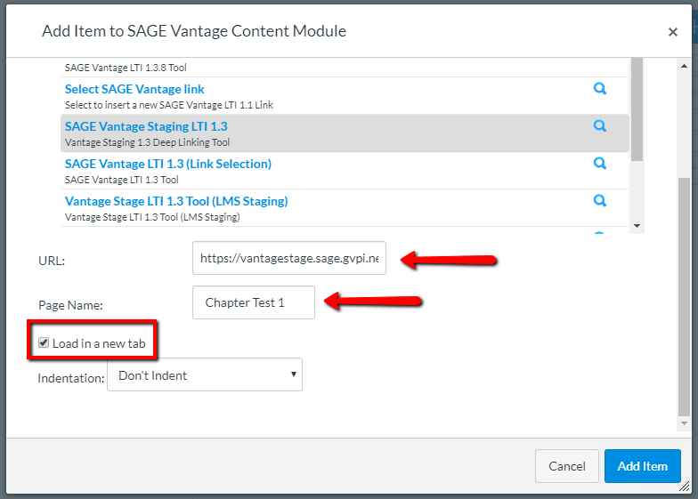

You will now see the link created in the Modules area of your course. You and your students can click on the link to access Vantage.

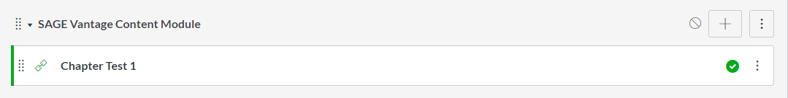

**IF YOU ARE SELECTING MORE THAN ONE LINK AT A TIME  
Y**ou can click on the Links and Grade Sync that you want to include in your module all at once.

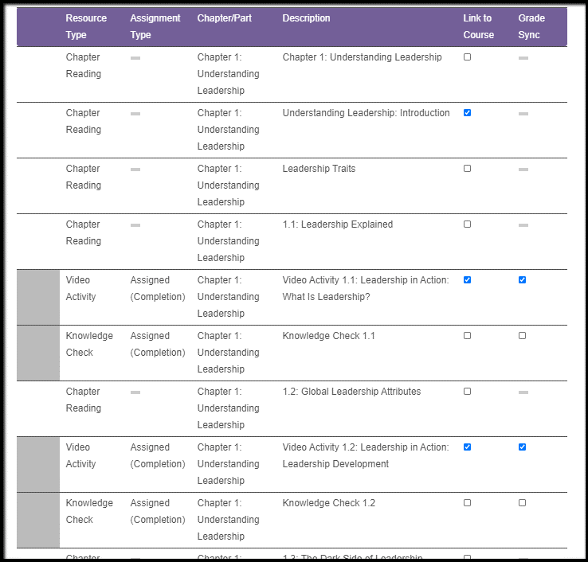

Click on Continue

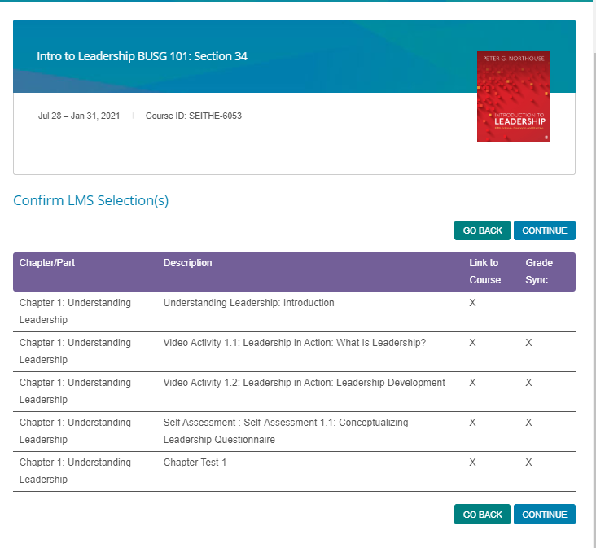

**Important Note:** Please take the time to review your selections! Extra links can be easily removed, but you cannot un-sync a grade item without assistance. If you mistakenly select an item to grade sync, please contact us at [LMSsupport@sagepub.com](mailto:LMSsupport@sagepub.com) for help.

Click Continue again

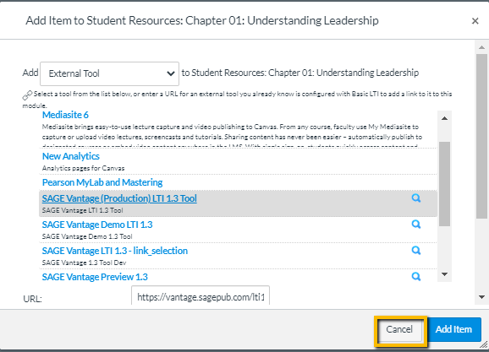

Click **Cancel**

[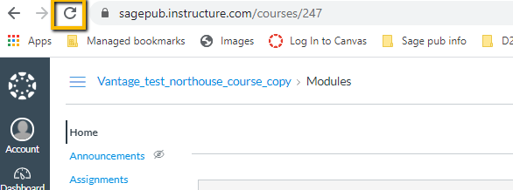](https://content.screencast.com/users/angela.seither/folders/Default/media/a759632f-d75a-402a-b071-181fb2dac4a7/LWR_Recording.png)

Refresh your screen and you will see that all of your links are now in your module.

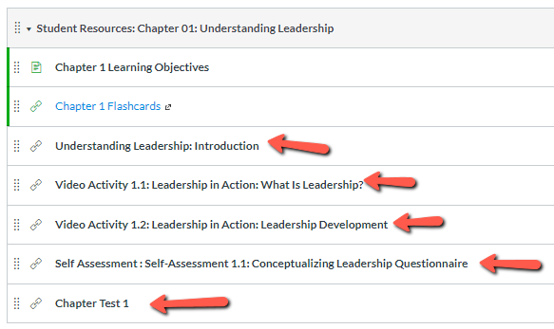

After you or any student has crossed over, you will see items on the Assignments page for each synced item. These are the placeholder assignments that allow the grades to appear in the Grade Center.

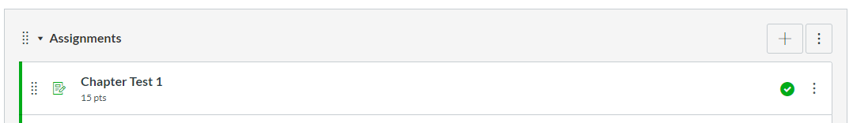

**Adding Due Dates in Canvas**

After you create the Vantage Deep linked activity in Modules,

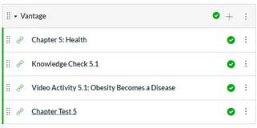

Click on Assignments in left hand navigation bar, click on the 3 dots on the right of the assignment and select edit.

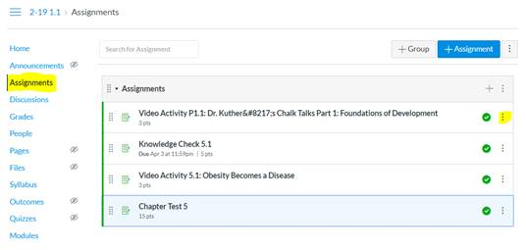

Add the due date and click on Save.

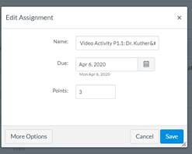

When the students and instructor go to Home they will see what is “Coming Up”.

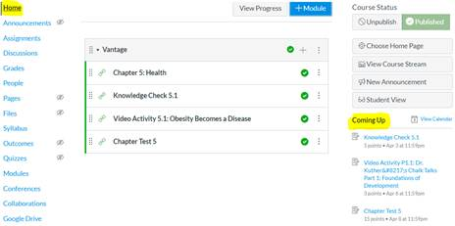

**Copying your course for additional sections or the next Term**

**Note:** Currently, course links can only be copied for the same instructor in Vantage. If multiple sections are being taught by different instructors, each instructor will need to create their own Vantage links.

Make a copy of your Canvas course, including the Vantage links, as per your school’s normal process. Once you have the new course, click on any Vantage link.

In this screenshot, the course copy confirmation is highlighted at the top. The links displayed are copied from the previous course.

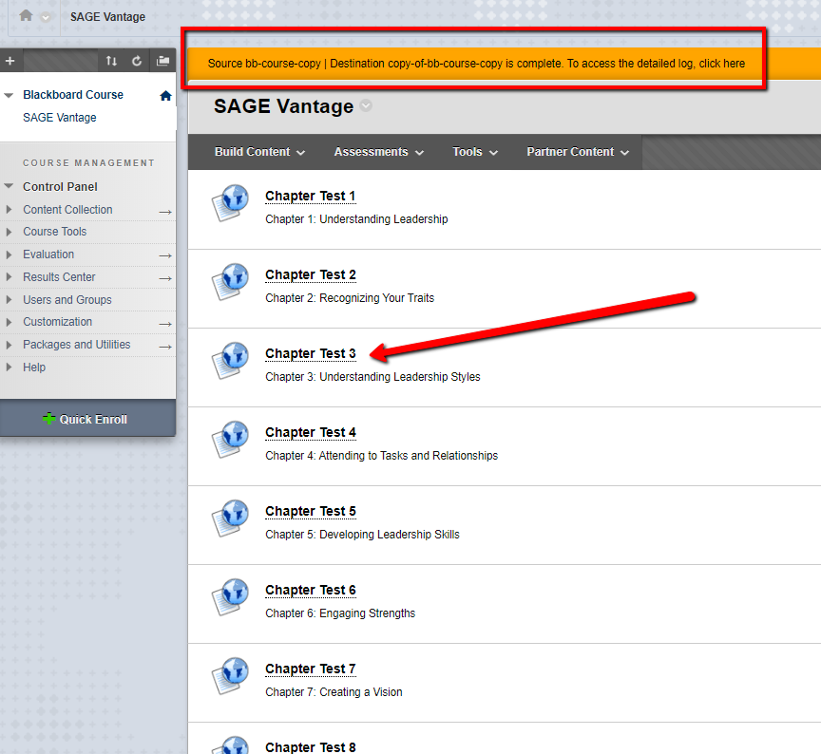

Vantage will recognize that the link you clicked on was in a copied course, and will ask you to pair your Canvas course to a Vantage course.

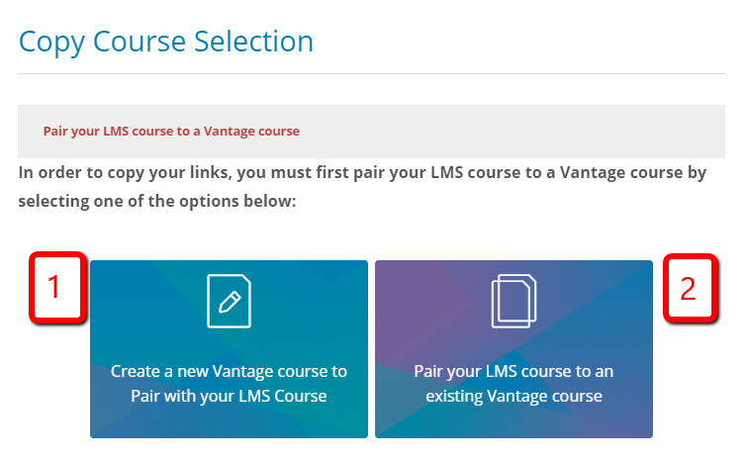

You create a brand new Vantage course (option 1), or you can choose to link to an existing course that you’ve already created at vantage.sagepub.com (option 2).

To create a new course, select the button on the left, and verify or edit the information on the next screen, as desired.

1. Course Title – This will default to the same title, plus some text that gives the copy date. You can keep the appendage, change it, or delete it.
2. Course Dates – This will default to the current course dates, but can be changed for future terms.
3. Copy All Dates checkbox – This will copy all of the assignment due dates to the new course. Use this only if you are teaching additional sections during the same term. Changing the course dates will not automatically update the assignment due dates within the course.

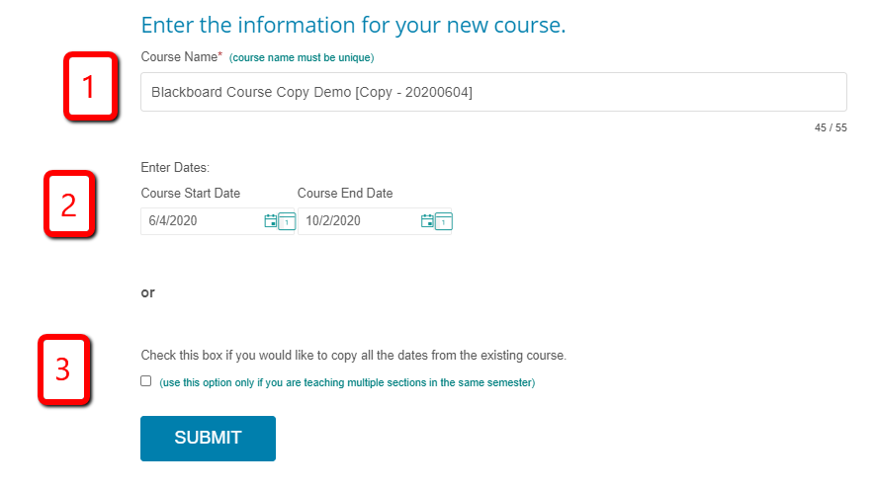

Once you hit submit, you will be taken to the destination of the link you first clicked on to trigger the course copy process (Chapter Test 3 in this example).

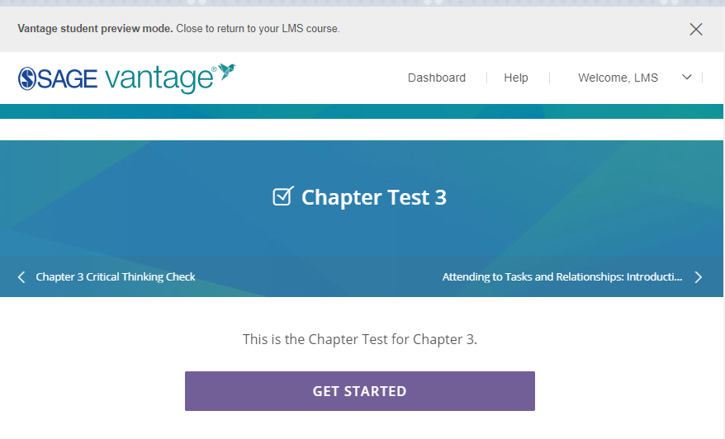

Once you’ve gotten this far, all the links in your course will point to your new course and no further action is required.