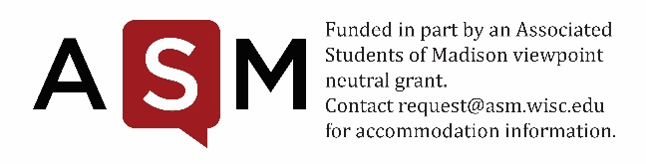
GSSF MIDYEAR BUDGET RETURN REQUEST
Student Services Finance Committee
Room 4301 ● 333 East Campus Mall ● 265-9020
SSFC Chair ssfc@asm.wisc.edu

Organization Name _______________________________ Submission Date________________
Organization Contact Name (must be an authorized signer) ______________________________
Organization Contact E-mail Address_________________ Phone Number__________________

SSFC Chair Signature ___________________(date) Approved______Denied __________

Midyear returns are a voluntary opportunity for groups to return funds no longer necessary. For example, funds may be returned for staff vacancies or unexpected cost savings resulting in underspent lines. Returns will be reallocated to the ASM Grant Allocation Committee for other RSOs to access through grants.

Please complete the information below to request your midyear return to SSFC for the current fiscal year. Please be aware that:
- Midyear returns may be submitted along with the Midyear Report or until Friday, March 12, 2021.
- Email one copy of this form to the SSFC Chair (ssfc@asm.wisc.edu). Once the document has been reviewed, the SSFC Chair will contact the organization regarding the request.
- Budget changes need to be made in whole numbers (versus cents).
- The SSFC Chair will approve midyear budget returns at his or her discretion. Upon request, returns may be brought before the whole Committee for review.

If you encounter any problems, or need any questions answered, please feel free to contact:

SSFC Chair ssfc@asm.wisc.edu
ASM Funding Advisor ksteigleder@wisc.edu

Midyear Budget Return Narrative:

- Please numerate the amount of each line to be returned.

- Please explain why the funds you are returning are no longer necessary.

