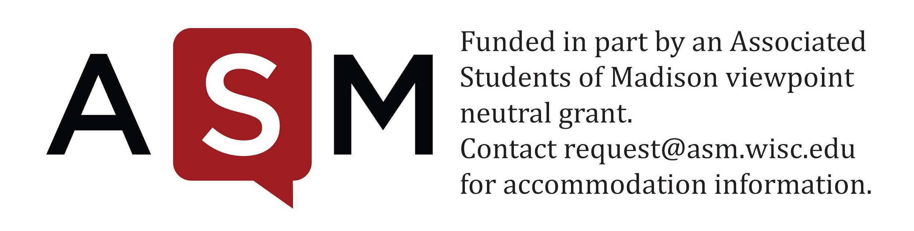
GSSF Lobbying Disclosure Form
Student Services Finance Committee
Room 4301 ● 333 East Campus Mall ● 265-9020
SSFC Chair ssfc@asm.wisc.edu

With respect to 2.01(5) of the ASM Bylaws:
2.01(5)- Lobbying Disclosure
2.01(5)(a)-
Representatives from any organization requesting funding and members of ASM bodies deciding on that funding will disclose any communication relating to the eligibility or funding request of the organization by filling out the “Lobbying Disclosure Form.” Information to be included on the form includes: 1) whether the communications in fact took place; and, 2) the substance of the communications.
2.01(5)(b)- Penalties
2.01(5)(b)1-
Any organization that knowingly, intentionally or willfully violates 2.01(5)(a) may be ineligible for funds for a period of one annual funding cycle by a majority vote of the ASM body responsible for the funding decision.
2.01(5)(b)2-
Any member of the ASM body that knowingly, intentionally, or willfully violates 2.01(5)(a) may be removed for one fiscal year by a majority vote by the members of that ASM body.

We, the representative(s) or member(s) of a GSSF-funded organization, and member(s) of the ASM Student Services Finance Committee / ASM Grant Allocation Committee / ASM Student Council, do hereby officially disclose that a discussion regarding the funding or eligibility of the GSSF group mentioned below took place on the date(s) listed.

Name of GSSF Group: Date:

Mode of Communication (please circle all that apply):

Phone Face to face Email Other (specify):

Name(s) and initials of GSSF Group Member(s):

Name(s) and initials of ASM Member(s):

List what Budgetary Line Items or Eligibility Criteria were discussed, and please be as specific as possible:

