Systems Engineering – Access Form
- Link to Access: http://platform.doit.wisc.edu/
- Click on “Systems Engineering New User Form”
- Create New Account for you or Create New Account for someone else

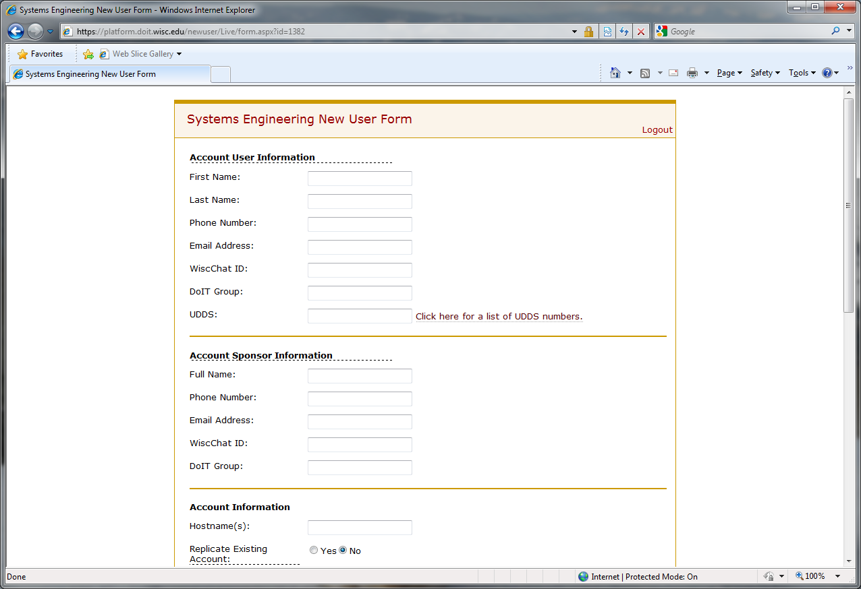
Fig. 1
- Enter customer’s information: name, phone, e-mail.
- Don’t worry about WiscChat ID
- Enter DoIT Group – if they are from DoIT
- UDDS: click on link to pull up the list (example: Human Resources is A02 2080)

- Sponsor info – enter your boss’s name here. DoIT Group = CAS

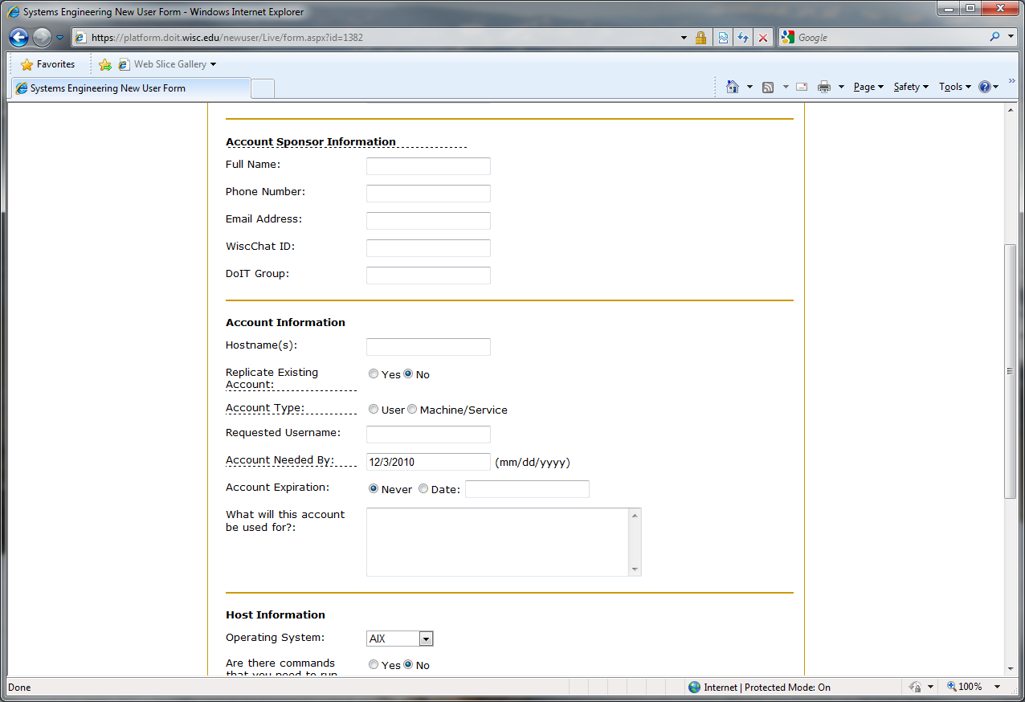
Fig. 2

- Account Information – hostname (example: Raspberry.doit.wisc.edu)
- Replicate Existing Account: Yes, enter who to copy from (if you have one in mind)
- Account type: User
- Requested username: enter your NetID logon account name here
- Account needed by: let it default, or enter a date
- Account Expiration: default to Never
- What it’s for? Enter a description - Tivoli Workload Scheduling (TWS)

- Host Information – Operating System (AIX for Raspberry)
- No > Yes (if there is) > No > Default > Windows Remote desktop
- SAVE

- Are there commands that you need to run with administrative privileges?
NO
- Special Instructions: TWS Regular users account

