

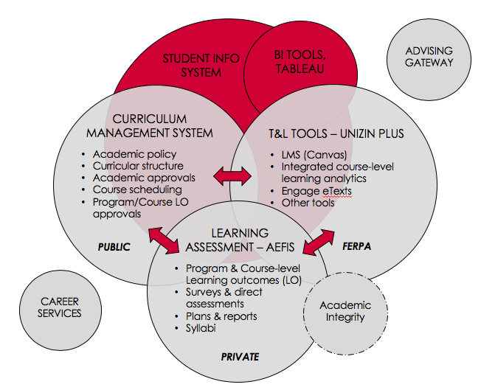**STUDENT DIGITAL ECOSYSTEM**

*A connection of systems to empower faculty, staff and students with new tools and capabilities to achieve success.*

UW-Madison is building a next-generation student digital ecosystem to better support faculty, staff and students. The ecosystem will connect university wide systems including student information, learning management and curriculum management systems, as well as digital assessment tools. The connection of systems will allow for interoperability and flexibility, improve information accessibility and consistency, and empower faculty, staff and students with new tools and capabilities to achieve success.

There are primary areas of tools within the digital ecosystem:

* Teaching and learning
* Learning assessment
* Curriculum management

The innovative aspect of the overall initiative is not that these tools are being used, in and of themselves, within separate spheres, but rather that there will be integration and interoperability within and among the spheres.

**Academic Integrity**

* Testing using Canvas and other digital tools
* Plagiarism

**Learning Analytics**

* Display
* Analyze, inform and question
* Act

# **Course/Classroom Scheduling**

**CROSS-CAMPUS TEACHING PROFESSIONAL DEVELOPMENT**

*Providing a professional development gateway for faculty and instructors of all career stages*

The gateway provides a way for faculty and instructors to easily review and select from the wide variety of cross-campus teaching professional development opportunities on campus, and create personalized pathways of professional development for continuous improvement throughout their careers. Currently, 250 faculty and instructors per year participate in programs and 2,000+ in workshops.

**Excel** –New program will support faculty and instructors, who have previously participated in campus teaching and learning professional development, to successfully *implement* what they learned – e.g., personalized, active learning strategies – specifically in mid-size (30-80 enrollments) courses.

**Inclusivity in Teaching Workshops** – Designed to raise awareness about issues impacting the academic success of women and underrepresented students, and to provide faculty and instructional staff with knowledge and skills to teach more inclusively. To date, offered nearly 20 sessions, serving 5 schools and colleges (SMPH, Law, Pharmacy, L&S and CALS), 190+ faculty, staff and graduate TAs.

**STUDENT ADVISING AND CAREER SUPPORT**

*Transforming how students connect to jobs, internships and career development opportunities on campus and beyond*

Handshake, UW-Madison’s new, primary tool for student recruitment and career event management, will provide better support for students searching for jobs, internships and campus career events. It will also better support high-quality, big-picture student-advisor conversations, and ultimately help enhance the WI Experience,   
  
the total student experience. To date, 12,500 students and 8,500 employers are already using the tool, with over 7,000 approved jobs and internships listed.

**ONLINE LEARNING INITIATIVE**

*Enhancing and scaling online course development to increase flexibility and expand access*

****The Online Course Initiative aims to enhance and scale high-quality online learning experiences across summer and academic-year offerings, in partnership with schools and colleges by supporting the development of online courses in any term.  
  
In alignment with campus priorities, the overall goals are to:

1. Advance excellence in teaching and learning through the WI Experience

2. Increase flexibility and options for primarily residential (“traditional”) students

3. New options that provide access and allow new groups of students to study at UW-Madison