Comprehensive Strategic Plan for Lifelong Learning 2020

University Committee
July 21, 2014

- What is the strategic direction for lifelong learning?
- The Vice Provost for Lifelong Learning has launched a strategic planning process to set the campus-wide direction for lifelong learning between now and 2020
- Three campus-wide goals have been set that keep the focus on the lifelong learner:
  - UW-Madison will create opportunities for transformative experiences and meaningful learning with every lifelong learner across campus
  - UW-Madison will reach more lifelong learners annually
  - UW-Madison will generate additional lifelong learning revenue annually

- Who is involved?
- All academic schools, colleges, and divisions across UW-Madison that have the potential to reach lifelong learners will be asked to collaborate with these strategic planning efforts
- A committee of Continuing Studies faculty and staff are actively engaged in the development of ideas that advance these goals within Continuing Studies and potentially expand support services to all academic schools, colleges, and divisions across UW-Madison
- A series of informational briefings will be scheduled throughout the summer with various leaders (e.g., University Committee, ASEC, Deans, etc.) and a Town Hall will be scheduled for early Fall 2014 to begin exploring how we as a campus can more effectively collaborate and support each other to better reach our lifelong learners and engage them in transformational learning

- What do the Chancellor and Provost expect to see this fall?
- A comprehensive campus plan that guides UW-Madison’s lifelong learning efforts between now and 2020

- What is the anticipated timetable?
  - The bulk of the strategic planning process will take place this summer and fall; a strategic plan to guide UW-Madison’s lifelong learning efforts should be complete by the end of the Fall 2014 semester

- Who should I contact with questions?
Jeffrey S. Russell, Ph.D., P.E., Dist.M.ASCE, NAC, F.NSPE
Vice Provost for Lifelong Learning
Dean, Division of Continuing Studies
jrussell@dcs.wisc.edu or 608-890-2318
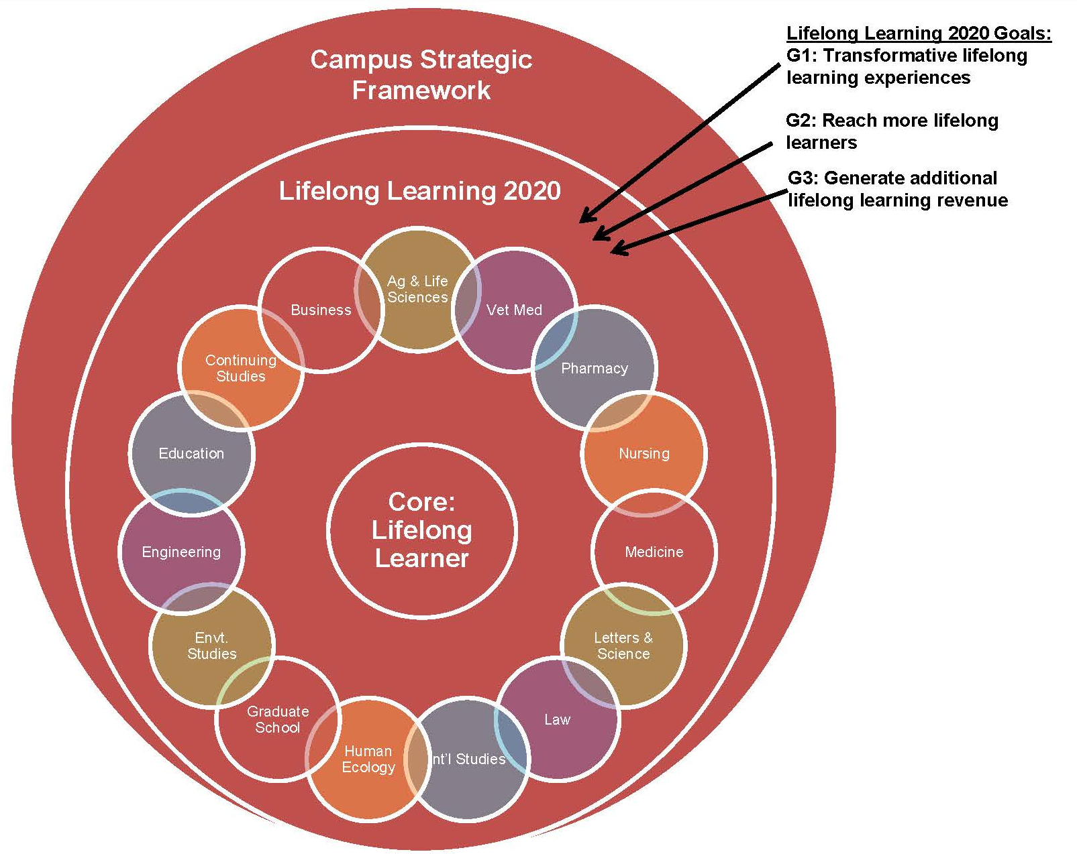
5-Year Campus Strategic Framework
Build-in Alignment and
Focus on the Lifelong Learner

Design for Meaningful
and
Transformational Experiences

