Agenda
Academic Staff Mentoring Committee
Tuesday, January 10 9:30-10:30 am
Room 338 “Berkowitz Room,” Brogden Psychology Building, 1202 West Johnson Street

9:30am Welcome
9:35am – 9:45am Academic Staff Office Budget Discussion (Smith and Daniels will join us)
Our committees main priorities is for our mentor and mentee match kick-off and two programs for that annually. One of their concerns isn't necessarily the food, but how to plan better. Some ideas:
  - Hors oeuvres for kick-off instead of meals. Our group will need to think about how we can facilitate this and still get people to come. Could we tell people to bring their own lunch or purchase it before they arrive and we provide drinks, snacks, or desert.
  - If we plan for snacks, try and order less or none at all because it often doesn't get eaten.
  - Going forward Jake has suggested that their office coordinate all room scheduling for our events.
Daniels suggested we reach out to Madison Academic Staff Network because they plan events. Perhaps CoP can look at ways to partner with them? We also need to focus on posting events of interests. CoP will look at how we can use FB for that.
9:45am - 9:55am Academic Staff Work Life Survey
Ratings by all Academic Staff:
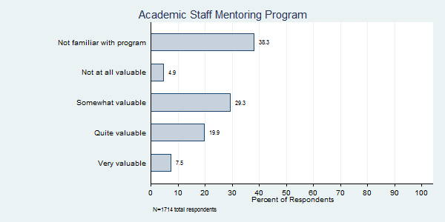
Ratings by Academic Staff who have used program:
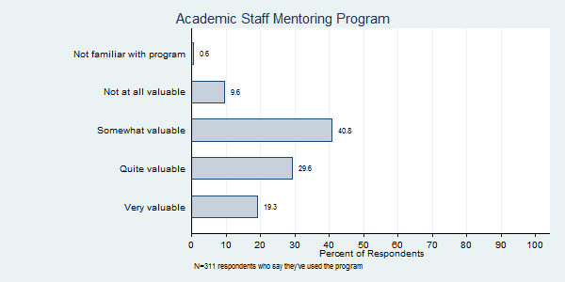
10:15am - 10:30am Sub-Committee
10:15am - 10:25am Events Sub-Committee (Barnes, Burk, Weltin)
- Event with Shelly Vils Havel, the Performance Management Coordinator from OHR, will be presenting on delivering effective feedback on 2/23/17
  - OHRD registration – group decided that we would like to use this so it is a transcript for people. We can also link to surveys through that.
- April Event ideas:
  - Engagement, Inclusion and Diversity for mentoring/mentee: https://provost.wisc.edu/climate.htm
  - work/life balance could have Shilagh Mirgain, PhD http://www.uwhealth.org/news/tips-for-moving-beyond-work-life-balance-and-finding-the-flow/44212
  - Emily Borenitsch to see if she has ideas https://www.ohrd.wisc.edu/home/Hide-A-Tab/NEWOfficeofTalentManagement/ThriveatUW-Madison/tabid/531/Default.aspxn fdr Wellness.
  - Someone who could discuss Center for the Healthy Minds Group
  - Sherry Rae at Employee Assistance about work/life balance

ACTION: Weltin will reach out to plan program in April on one of the above topics.

10:25am – 10:30am Mentoring Community of Practice Sub-Committee (renamed from Campus Collaborations Sub-Committee) (Stephens, Solcz)

  - Working on potential for May tour and program for next year.

Resources Sub-Committee (Elder, Gill, Weltin)
  - Going forward our group needs to do a better job sharing programs we discover across campus.
ACTION: Each meeting we will devote time to discover a resource we can share with our mentor/mentee matches. Then send it out via email, FB and LinkedIn. If you see something earlier please share too!
10:30 am Adjourn
Next ASMC meeting: Tues, 2/14/17 9:30-10:30 am

