For Wisconsin and the World
Focusing a Great University on Its Core Mission, Public Purpose, and Global Reach

DRAFT FOR DISCUSSION

Campus Colleagues,
Over 6000 faculty, staff, students, alumni and friends participated in UW-Madison’s self-study in 2009. The commitment, energy, and creativity from those voices resulted in a visionary guide to help shape UW-Madison’s future, including a strategic framework. After significant advances on the priorities outlined in 2009, this is a draft updated version, charting a course for 2015-2019.

The vision, guiding principles, and priorities shown here are carried forward from our current plan as they remain relevant. The activities for each priority are updated – see pages 4-5. Please review these pages in particular. We welcome your comments and suggestions. Please send your comments to Maury Cotter at mcotter@wisc.edu by December 10, 2014.

We are committed to advancing the bold visions outlined by our colleagues and constituents.

Sarah Mangelsdorf, Provost

A Strategic Framework for the University of Wisconsin-Madison
2015-2019

For Wisconsin and the World
Focusing a Great University on Its Core Mission, Public Purpose, and Global Reach
DRAFT November 11, 2014

Insert letter from Chancellor/Provost

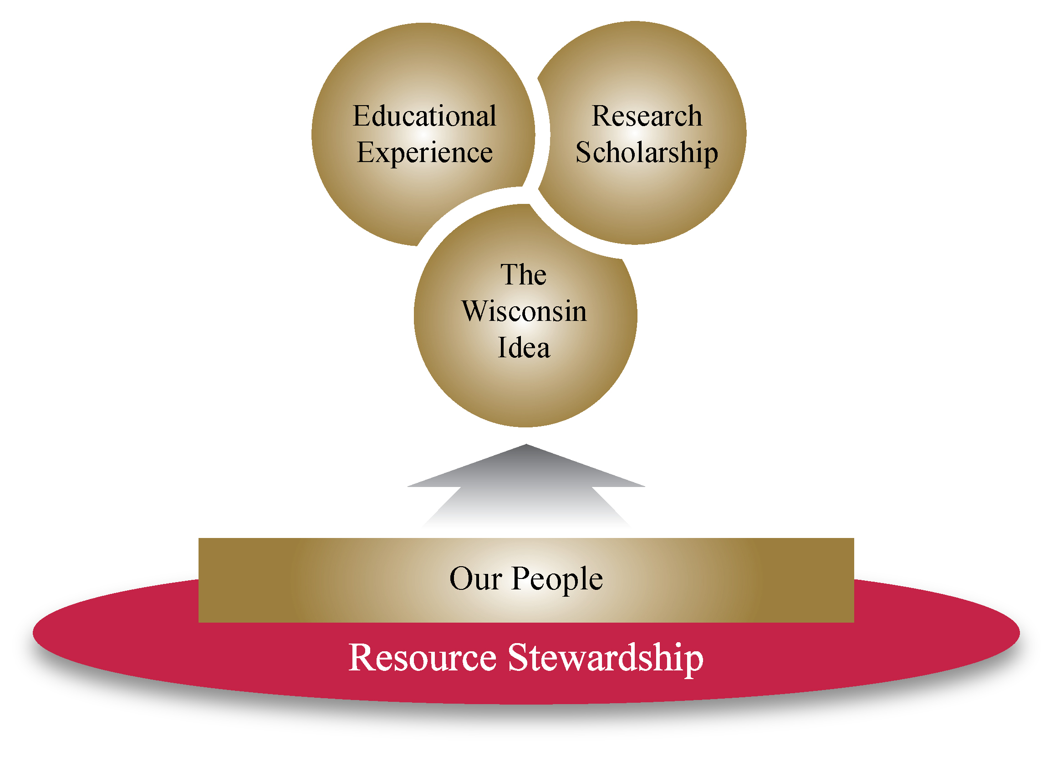
www.chancellor.wisc.edu/strategicplan

Our Vision
The University of Wisconsin-Madison will be a model public university in the 21st century, serving as a resource to the public and working to enhance the quality of life in the state, nation, and the world.

The university will remain a preeminent center for discovery, learning, and engagement by opening new forms of access to citizens from every background; creating a welcoming, empowered, and inclusive community; and preparing current and future generations to live satisfying, useful, and ethical lives. In partnership with the state and with colleagues around the world, the university’s faculty, staff, and students will identify and address many of the state’s and the world’s most urgent and complex problems.

Our Guiding Principles
As an institution and as individuals, we are guided by the following principles:
- We promote the highest standards of intellectual inquiry and rigor, in keeping with the university’s proven commitment to the “continual sifting and winnowing by which alone the truth can be found.”  - We support learning for its own sake, throughout our lives, as a service to the greater good.  - We fiercely defend intellectual freedom and combine it with responsibility and civility so that all who work and live on our campus can question, criticize, teach, learn, create, and grow.  - We observe the highest ethical integrity in everything we do. | - We believe in the importance of working with and learning from those whose backgrounds and views differ from our own.  - We share the belief that neither origin or economic background should be barriers to participation in the community  - We are committed to being responsible stewards of our human, intellectual, cultural, financial, and environmental resources.  - We promote the application of research and teaching to issues of importance for the state, the nation, and the world, and we place learning and discovery in the service of political, economic, social and cultural progress.

Our Priorities
- Educational Experience
- The Wisconsin Idea
- Research and Scholarship
- Our People
- Resource Stewardship

Our Priorities and Initiatives

Educational Experience
- Improve access by increasing need-based financial aid
- Transform teaching, learning and engagement to inspire students and empower communities.
- Pivot the student experience to pervasive active learning
- Engage students in Wisconsin and international experiences, and learning through service and civic engagement
- Build innovative professional masters-level degrees and other lifelong learning experiences
- Improve learning outcomes and academic achievement for all students.

The Wisconsin Idea
- Work in partnership with our community, UW System schools, Wisconsin corporations, and government to bring value to the State of Wisconsin.
- Promote economic development through our campus technology transfer ecosystem, in partnership with the community
- Extend our educational mission with new technology and partnerships to Wisconsin and the world.
- Leverage our distinctive interdisciplinary strength to address some of the state’s and world’s complex problems.

Research and Scholarship
- Nurture excellence in research, scholarship, and creative activity across all divisions
- Optimize the research and scholarship infrastructure of the university
- Strengthen our influence in national decision-making around research policy and funding
- Engage our interdisciplinary strength to generate creative solutions
- Ensure graduate student support and opportunities that enhance their experience and future success.
- Support the continued high level of integration of research and graduate education that has been the hallmark of the UW-Madison

Our People
- Ensure UW-Madison has a workforce that is highly talented, engaged, and diverse by implementing our new personnel/human resource system.
- Enhance the strength of our campus through diversity and inclusion by implementing the campus Diversity Framework.
- Ensure our ability to attract and retain talent by making progress toward competitive compensation relative to our peers and market medians.
- Nurture growth of our people through professional development and performance excellence.

Stewards of our Resources
- Promote resource stewardship, improve service delivery and ensure administrative capacity.
- Create a stable and sustainable financial structure through the implementation of a transformed budget model
- Identify and pursue new revenue sources.
- Promote environmental sustainability through our own campus operations, integrated with research and education.
- Sponsor a comprehensive campaign to invest in the future of the university and the students, faculty and staff who will shape the future of Wisconsin and the world.

