Appendix E: Map of Surface Class C Airspace

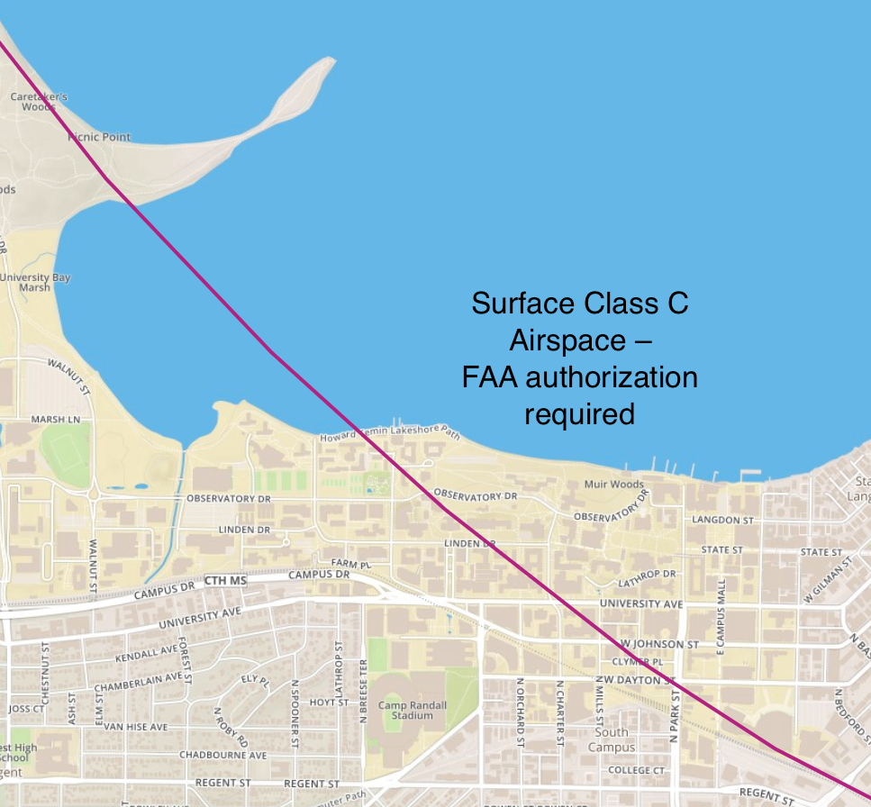
Figure 1 Areas of campus above and to the right of the magenta arc are located within surface-based Class C airspace. Within this area, FAA authorization for UAS operations must be requested via www.faa.gov/uas/request_waiver.

