Understanding Data Sharing - IPD
As a condition of publication of clinical trial results, ICMJE journals require that a Data (IPD) Sharing Statement be included in the ClinicalTrials.gov registration.
- Applies to clinical trials that begin enrolling participants on or after January 1, 2019.,
- The statement must be in the original ClinicalTrials.gov registration.
- The answer to “will data be available?” must be No or Yes.
(per official ICMJE correspondence – even though ClinicalTrials.gov provides an “Undecided” option)
- The answer can change; explain in the Plan Description when updating the record.
- Should match the data sharing statement required to be submitted (as of July 1, 2018) with the results manuscript for publication in ICMJE journals.^{2,3}

IPD Sharing Statement Examples
The statement consists of answers to seven questions; see the ICMJE press release for complete details, including the following table² with examples of statements that fulfill their requirements:
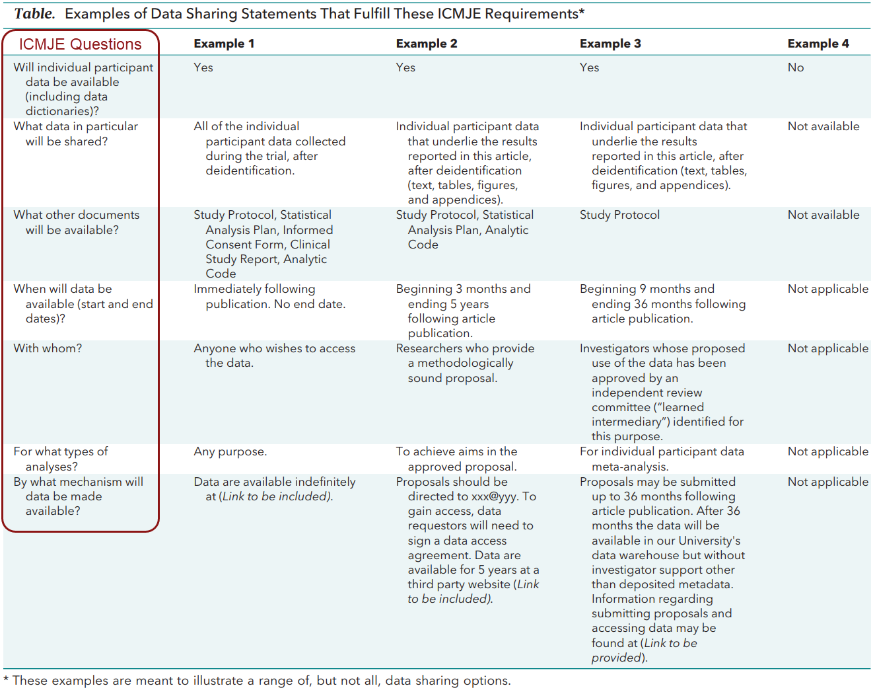

Mapping the Data Sharing Statement in ClinicalTrials.gov
ClinicalTrials.gov provided the IPD Sharing Statement Module to accommodate data sharing statements.
- Log into the Protocol Registration and Results System (PRS)
- Open the ClinicalTrials.gov study record
- Open the Protocol Section, then Edit the IPD Sharing Statement Module
- Answer the ICMJE questions using the corresponding PRS data elements:

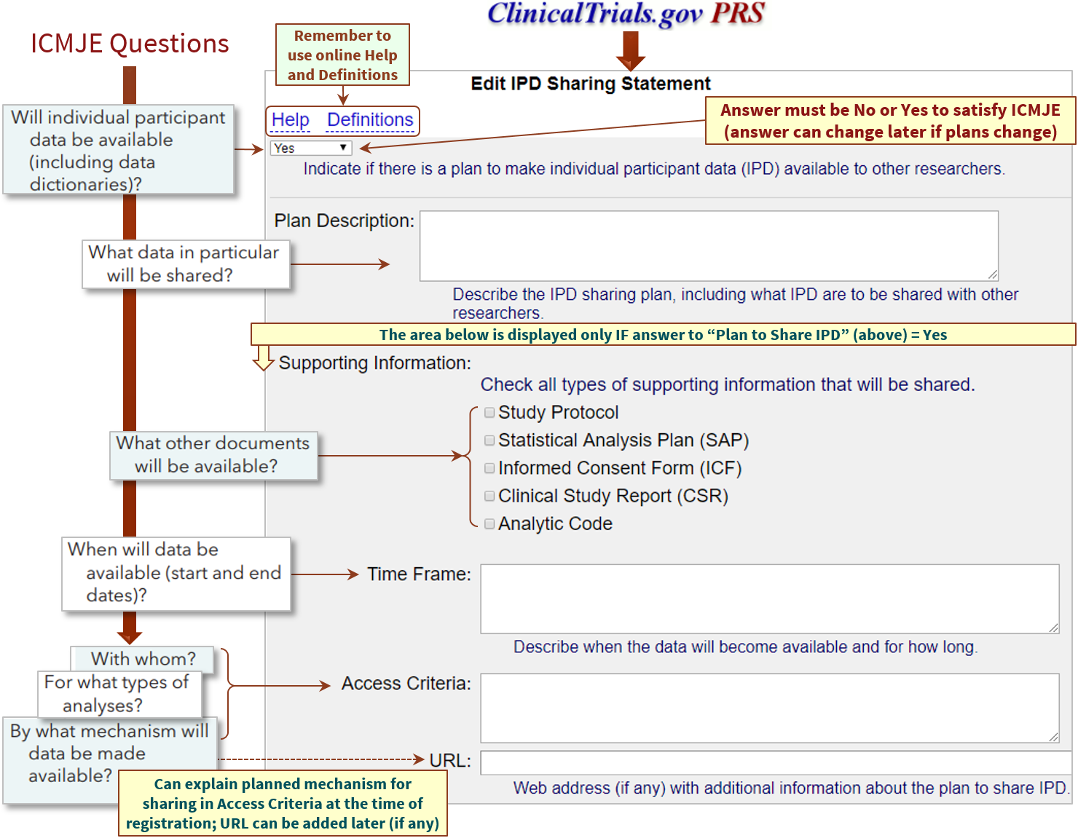

Questions? UW-Madison CT.gov Support
Office of Research Compliance
(608) 890-1241
ClinicalTrials.gov_Support@research.wisc.edu

IPD = Individual Participant Data; “data sharing statement” and “IPD sharing statement” are synonymous
Taichman et al., Data Sharing Statements for Clinical Trials: A Requirement of the International Committee of Medical Journal Editors (ICMJE). Ann Intern Med. 2017 Jul 4;167(1):63-65
http://www.icmje.org/recommendations/browse/publishing-and-editorial-issues/clinical-trial-registration.html, section 2
Mapping is based on ClinicalTrials.gov Protocol Data Element Definitions (https://register.clinicaltrials.gov/prs/html/definitions.html)

